Wireshark Lab - Exercise 1

Start Wireshark and capture packets, when start capture do that:

* Start capture For quarter hour ✔
* Ping from your computer ip and default getaway ✔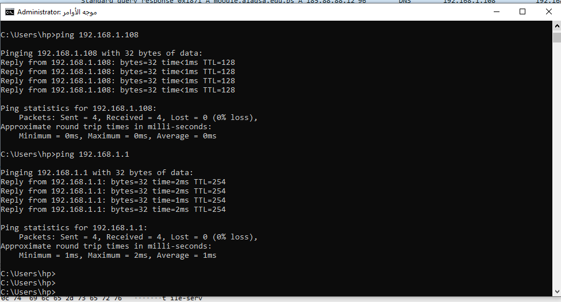
* Open al-Aqsa university web site ✔
* Open some videos ✔

After finished capture do the following questions:

* *Filter all packets made by your device (Write the filter and give screen shot)*

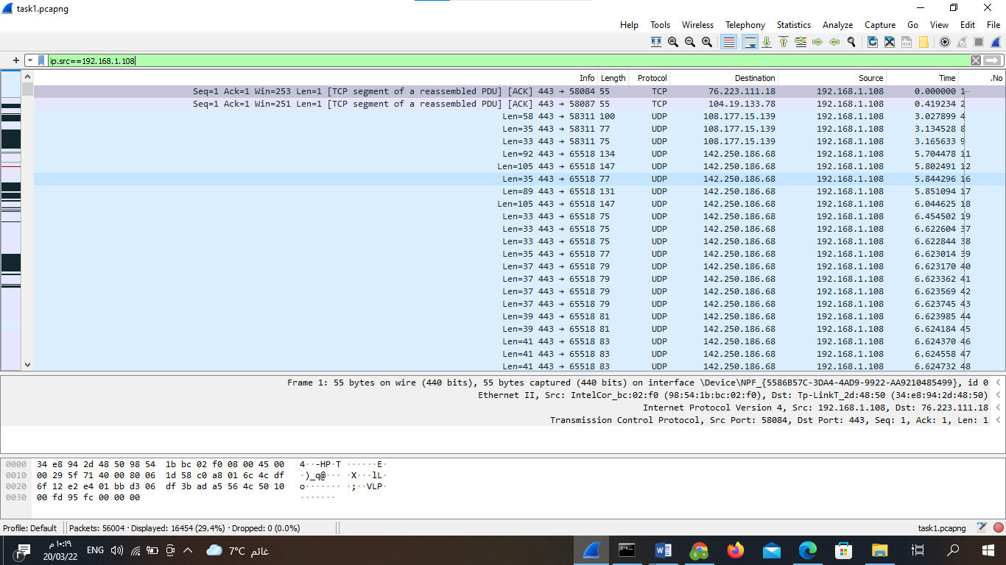

* Display all http , dns packets (Write the filter and give screen shot)

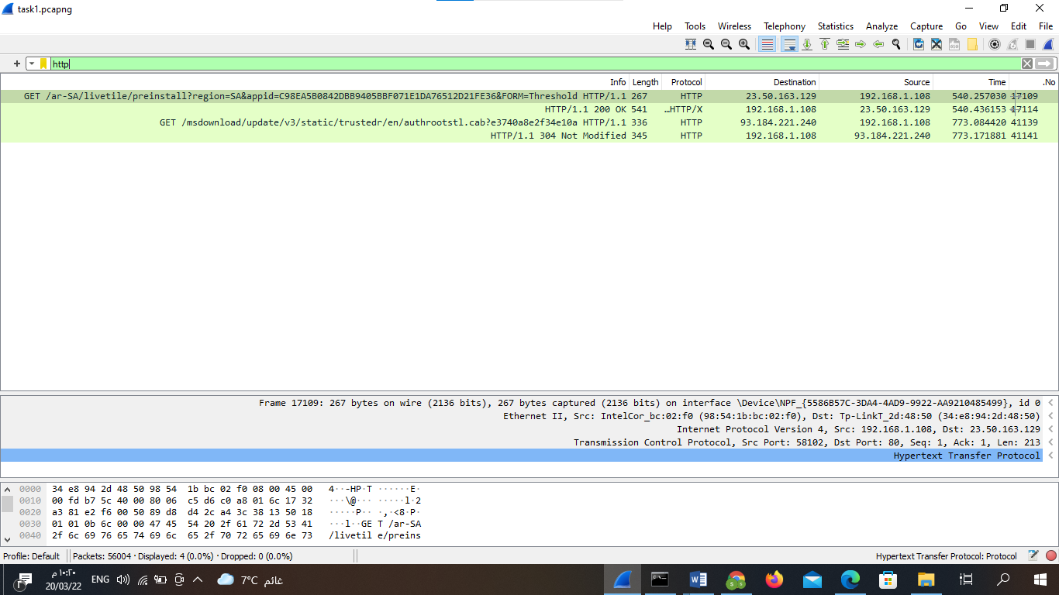

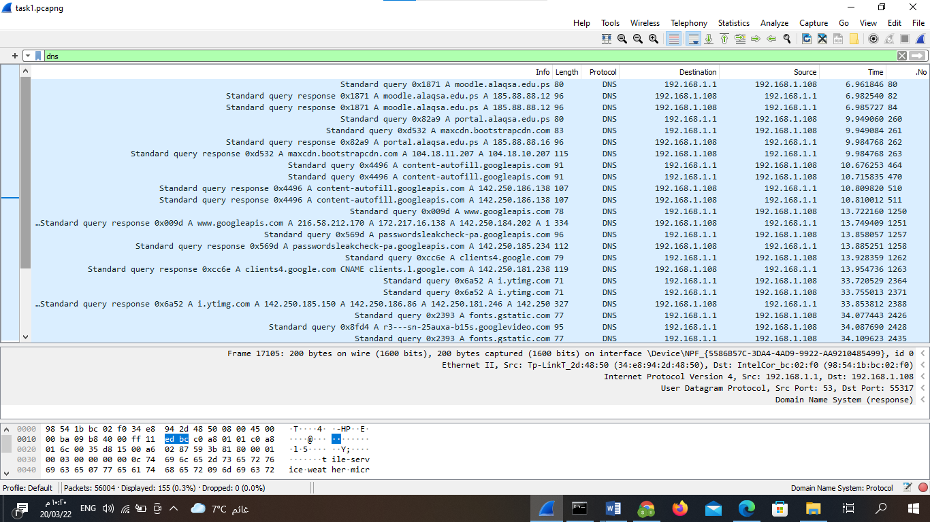

Upload capture file in Moodle and word file contains pervious questions

**File name:task1**

**Best Wishes**